Nuclear Beta Decay Analysis: Procedure Proposal

Alex Stothart - 10065239, Colin MacLeod – 10151666, & Zach Mirotta – 101…

ENPH 453

January 20th, 2018

## Goals

This experiment aims to accomplish 3 principle goals:

* Observe β- decay of 128I nuclei
* Estimate the mass of the anti-neutrino produced in the decay
* Determine the half life of the 128I isotope

The energy values of the electrons emitted in the decay will be recorded, and the shape of this energy spectrum can be examined to verify if it matches the expected distribution. The upper limiting energy value observed can be used to estimate a value for the anti-neutrino mass. The number of observed decays can be recorded over fixed time intervals, and this data can be fit to an exponential decay curve to obtain a value for the half-life of the isotope.

## Background

## Beta Decay

Beta decay is a form of radioactive decay involving the transformation of a neutron into a proton or vice versa. Beta decay emits a high-energy electron or positron, known as beta rays. There are three types of beta decay: β+ decay, β- decay, and electron capture. β+ decay involves that transformation of a proton into a neutron, emitting a positron and neutrino. Β- occurs when a neutron transforms into a proton, emitting an electron and anti-neutrino. Electron capture is the process of an inner electron being captured by a proton in the nucleus, transforming it into a neutron and emitting a neutrino. Several factors contribute to beta decay; mainly, the total number of nuclides and the number of protons. If there is a large number of protons in an atom the Coulomb repulsion between them increases the energy, in which case it would be favourable to transform proton into a neutron, resulting in β+ decay. If there is a large number of protons in a nucleus then, based on Pauli’s exclusion principle, neutrons will be forced into high energy states, in which case β- decay may occur. This lab will be studying the β- decay of 128I. A method of inducing β- decay is to enrich a stable source with additional neutrons. The added neutrons will likely decay to protons, depending on the source. The energy of the process is termed the Q value. The Q value is the difference between the mass of the reactants and products. The Q value of 128I β- decay was calculated to be 2121 keV by subtracting the mass excess of 128Xe from the mass excess of 128I. The kinetic energy of the emitted electron, mass of the emitted neutrino, and kinetic energy of the neutrino sum to the Q value. The mass of the emitted neutrino can be calculated by subtracting both kinetic energies from the Q value.

## Beta Spectrum

The beta spectrum is a histogram plot of the energy of the electron emitted in β- decay. The energy of the electron can be used to determine the kinetic and mass energy of the emitted neutrino. At the maximum possible electron energy, the neutrino would theoretically have no kinetic energy. If the neutrino has no kinetic energy, then the energy that is not accounted for in the electron kinetic energy is the mass energy of the neutrino. The maximum kinetic energy of the electron is the x-intercept of the beta spectrum. The β- spectrum shape is that of a gaussian distribution skewed towards low energies. The distribution is skewed because of the Coulomb force slowing the electrons down to lower energies as they are emitted. For β+ decay the spectrum is skewed to high energies for the same reason. The spectrum can be linearized into a Kurie plot which clearly shows the intercept. The spectrum data is linearized by plotting the square root of the counts divided by the respective Fermi function versus energy.

## Apparatus

A sodium iodide crystal, specifically a Bicron 3M3/3 NaI crystal, will be used as both the source and detector for the beta decay in this experiment. This crystal will be surrounded by lead in order to isolate it from other radiation sources that may be present. Using neutron capture, the iodine 127 in the crystal will be used to create iodine 128, which is a source of beta minus decay. The crystal will also be used as a scintillator detector, and a photomultiplier tube (PMT) will be used to capture the signal given off by the crystal. This photomultiplier tube will be biased at 800 volts by an Ortec 459 0-5 kV bias voltage supply. The signal through from the photomultiplier will be amplified through a Ortec 572A amplifier, so that it can be read by a multichannel analyzer (MCA). A Tektronix TDS3012B 2 channel oscilloscope will be used to monitor the signal from the amplifier so the gain can be set to an appropriate level. The data from the multichannel analyzer will be analyzed using a PC running Maestro32 MCA software, where the data can be collected and stored.

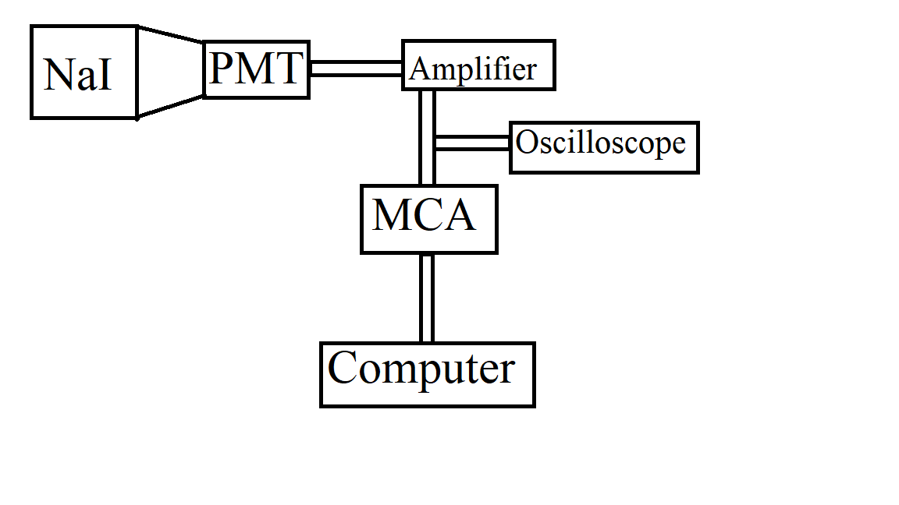

Figure 1: Diagram of Experimental Apparatus

## Experimental Procedure

### Setup

Prior to the collection of nuclear decay data, several preparatory steps needed to be completed to ensure that the experimental results are valid and useful.

#### Energy Range Selection and Calibration

The emitted electron energies were amplified, and then recorded using MCA software and sorted into channels based on energy level. This data was plotted in a histogram with a bin corresponding to each channel. Before this could be done, however, the gain of the amplifier needed to be adjusted to an appropriate value, and the resulting calibration relation between energy level and channel needed to be determined. This was done as follows:

1. The __ isotope was selected for use as a reference, since the combination of two expected γ-decay values lead to a peak with an energy of approximately ___ keV, a value just greater than the Q-value of the β-decay studied. The gain was tuned so that this peak fell at the far right edge of the histogram display. This was done since no electrons can be emitted with an energy higher than the Q-value of the decay, so all data relevant to the experiment will fall to the left of the location of the __ keV peak.
2. __ other isotopes were also selected for use as a reference, as they were expected to produce γ-decay peaks at ___, ___, ___, ___, and ___ respectively. The decay data resulting from these isotopes was recorded, so that gaussian distributions could be fit to the produced peaks, giving mean channel number, and error on the mean values. A linear fit can be performed on the mean channels numbers at each recorded peak to determine a calibration factor between energy level and channel number.

When experimental data is collected, the emitted electron energies will be recorded and sorted in a histogram using the MCA software. Before emitted electron energies could be recorded and sorted int histogram binsPrior to this, the energy values corresponding to the histogram channels must be calibrated, and the upper end of the range over which this histogram spans must be selected so that it encapsulates all expected energy values, and yields channel widths small enough to provide as much precision as possible. No emitted electrons are expected to have an energy greater than the Q-value of the decay, namely 2121 keV, meaning the upper limit of the histogram bin should be set slightly above this value. A radioactive isotope that undergoes γ decay with a single, known energy slightly greater than the 128I Q-value will be inserted into the scintillator, and the resulting events will be observed on the monitor of the computer using the MCA software. The gain of the amplifier will then be tuned so that these events fall at the upper limit of the data collection range, and the MCA channel in which these decays fall will be noted and recorded. A second radioactive isotope that undergoes γ decay with a single, known energy slightly lower than the I128 Q-value will then be inserted into the scintillator. The resulting events observed on the computer monitor should fall at a point near the upper end of the data collection range, but slightly lower than the events resulting from the previous radioactive isotope. The channel in which these events fall will also be recorded. This ensures that the highest expected electron energies resulting from the β- decay will fall near the upper limit of the collection range, but will never exceed it. The known γ decay energies of the selected isotopes and the recorded channel numbers can be used to obtain a linear calibration relation between all channels and energy values.

#### Energy Resolution Determination

The intrinsic lack of precision of the data collection and recording equipment must be accounted for when analysing experimental data, meaning the resolution of the energy value recordings must be determined. This can be done using of five or more radioactive isotopes that undergo γ decay with a single, known energy. The isotopes should be selected so that the respective γ decay photons released have a range of energy values comparable to the range over which experimental data will be collected, allowing the resolution to be observed as a function of particle energy. Each isotope should be inserted into the scintillator in turn, and the full width at half maximum of the peak observed on the display corresponding to the decay should be recorded for each isotope. These values represent the resolution of the energy readings at the respective particle energy values. This data can also be used to confirm the linear calibration relation established earlier between channel number and energy value.

#### Background Noise Recording

The recorded experimental data will be affected by the background events observed by the PMT, which will limit the accuracy of conclusions drawn from the data. As a result, these background events must be recorded over an extended period of time, and subtracted from the experimental data. The data collection apparatus will be turned on at the end of a lab period, but the NaI source will not be activated, meaning all data collected results from background events. The observed events will be recorded until the beginning of the next lab period, at which point the data will be saved.

### Data Collection

Once all the setup steps have been completed, the beta decay can be observed, and the experimental data collected. The Iodine in the NaI crystal will be activated for roughly 10 minutes using the AmBe neutron source. Once activated, it will then be reconnected to the PMT, and the β- decay events will be observed. The energy of the electrons emitted in the decay will be recorded in the previously calibrated histogram using the MCA. The data recording will be done for roughly 1-1.5 hours, since the half-life of 128I is approximately 25 minutes, meaning relatively few events will be observed beyond this point. The data set will be saved at fixed 5-0 minute intervals, so that the total number of events observed over each interval can be determined. This will be used to calculate the decay rate/half-life.

## Data Analysis

Once the data has been obtained, the background radiation will be removed by comparing the electron energy data to the background data taken earlier. A deconvolution will also be undertaken in order to remove any effects of the detector resolution. This will be done using the detector energy resolution data collected in the experimental setup. This resolution will be in the form of a Gaussian function which can be deconvolved from the data. The resolution of the detector was analyzed at different energies, so that the correct resolution is used in the deconvolution, as the resolution may be energy dependant. The data will be converted to a Kurie plot in order to analyze the intercept, which determines the end point energy. In order to convert the data to a Kurie plot, the square root of the number of counts divided by a fermi function will be compared to the energy of the electron.

## Physics Analysis

Once the end point energy of the electron has been established, the total energy contained in the neutrino can be evaluated by comparing the endpoint energy to the Q value of the reaction. In an ideal system, the neutrino would be created with no kinetic energy, so the total energy calculated for the neutrino would be contained solely in its mass, and thus the mass of the neutrino can be calculated. However, this situation is unlikely to be seen using the equipment in this experiment, and so the energy of the neutrino will be used to determine a rough upper limit on the mass of the neutrino. It will also be useful to examine the shape of the spectrum produced in the experiment, as it will be helpful for examining sources of background radiation, as well as matching the curve to the expected model through use of a Kurie plot. The intercept of the Kurie plot will be used for determining the endpoint energy of the electron. Calculations of the decay half life of 128I will also be carried out, and compared to the known half life of 24.9 minutes (Isotope Data for Iodine 128, 2018).

## Safety Concerns

Several safety factors need to be considered when executing the experiment. The photomultiplier tube requires a very high voltage of 800V to operate, so caution must be used in operating the photomultiplier tube and its voltage supply. Also, the NaI crystal will be surrounded by lead, which is toxic. Gloves will be worn when handling lead objects. Several sources of ionizing radiation will be required to calibrate the detector, so techniques to minimize any possible exposure to radiation will be used. A neutron source will be required to activate the NaI crystal, so caution must be used when inserting the crystal into the neutron source.

# References

*Isotope Data for Iodine 128*. (2018). Retrieved from periodictable.com: http://www.periodictable.com/Isotopes/053.128/index.p.full.dm.html